Lexicographic Structure Recognition (Parsing) Based on Text Style and Syntax
Abstract
This article discusses technical and theoretical questions aroused during the process of lexicographic structure recognition of human readable text provided by Jumakunova’s Turkish-Kyrgyz dictionary. Data structuring task was accomplished according to the lexicographic schema of the given dictionary using markup technology and text entity recognition techniques. Text entity recognition rely on the text style (formatting and layout) patterns and explicit text delimiters (syntax of the dictionary) definition by means of (X)HMTL and CSS parsers. Output of the parsing is a machine-readable (X)HTML tree which conveys dictionary logic. Later this (X)HTML tree must be transformed to XML/TEI P5 terminology in order to provide global data interchange.
Key words: text entity recognition, lexicographic structure, parsing, formatting, layout, delimiter
Organization of the Article
First section provides theoretical background for text reading process both by human and computer.
Introduction
Human readable dictionary texts may be viewed as logical (lexicographical), organizational (editorial), and aesthetical (typographical) entities [TEI Consortium, 2015], or simply saying they have a form (expressed via layout and font) and logic. Logically dictionary consists of series of entries, and entries in turn have their own tree like structure which is determined by a lexicographical standard (add Figure where entry is annotated by hand). Every structural unit performs its logical function, i.e. it conveys some metadata about its content. But the central question of the work is how human beings discern that units and how this process may be delegated to computers.
In the lexicographic context logical structure recognition process doesn’t invade inside the word boundaries, such an analysis in Natural Language sometimes referred as syntactic analysis(cite is needed). As an output of this analysis an intelligence agent has a syntactic structure which reflects semantic relationship between text level units (cite is needed). The process of syntactic (in our context lexicographic) structuring is the one of the main steps towards semantics extraction process which is the final point of meaningful reading. The chain of processes leading to understanding of the text being read depicted in Figure1. This processes start from seeing and end with semantics extraction or simply saying getting the meaning of the text.
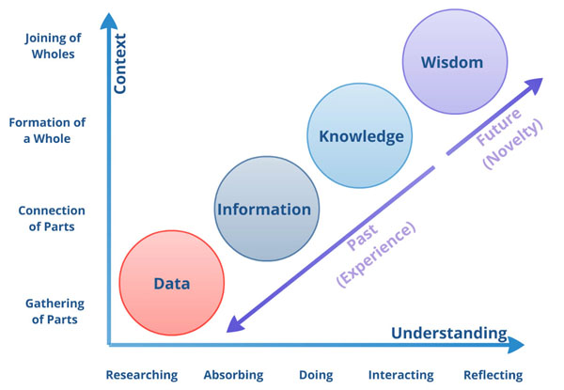
Figure 1: Growth of Data Quality
The process of logical structure recognition by machine is copied from the process of logical structure recognition by human.
Logic is expressed by means of form. Form may be different but logic stays permanent.

Figure 2. Text Processing in Terms of a Human Being
Color Distinction Knowledge
Shapes Distinction Knowledge
Character Knowledge (Alphabet)
Text Entity Delimitation Knowledge (Syntax)
Suffix/prefix Delimitation Knowledge (Morphology)
Concepts & Entity Relationships Knowledge (Lexicon & Grammar)
TEXT
Semantics
Visual Information
Visual Perception
Flat Shapes Recognition
Shaped Information
Reading
Shaped Textual Information
Syntactic Analysis
Syntactically Structured Information
Morphologic Analysis
Syntactically & Morphologically Structured Information
Semantics Extraction
dfsd
Colors DB
Area Shapes DB
Characters DB
Text units recognition rules(Syntax)
Morphemes DB and delimitation rules (Morphology)
Lexicon and Concepts RelationshipDB (Lexicon & Grammar)
Image
Scsnning
Text Area Recognition
Layout Data
Character Recognition
Layout Structure
Syntactic Parsing
Syntactic Structure
Morphologic Transducing
Syntactic & Morphologic Structures
Semantics Extraction
TEXT
Semantics
Computer
Figure 3. Text Processing in Terms of a Computer Agent
Different Options to Process Textual Information
Colors DB
Area Patterns DB
Charasets DB
Text Units Delimiters or Patterns DB
Word Units DB
Concepts and Rules DB
Image
Scanning
Text Area Recognition
Layouted Data
Character Recognition
Layouted Textual Data
Syntactic Parsing
Syntactical Parse Tree
Morphologic Parsing
Syntactic& Morphologically Annotated Data
Semantics Extraction
TEXT
Semantics
Computer

Programmers usually call it as ‘front-end’ and ‘back-end’

